Tukaram Krishnaji kolekar Arts and Commerce COLLEGE, Nesari
At/post ,Nesari, Tal : Gadhinglaj.Dist: Kolhapur, Maharashtra, India.
Shikshan samiti K|| Nesari’s
G R N: NGC 3595/NMV/137/95 MS –3 Date: 4/8/1995
President
Adv. H.T. Kolekar ( B.Sc. L.L.B)
Principal
Dr.S.B. Bhambar _{MA M.Phil Ph.D Ph.D}
.
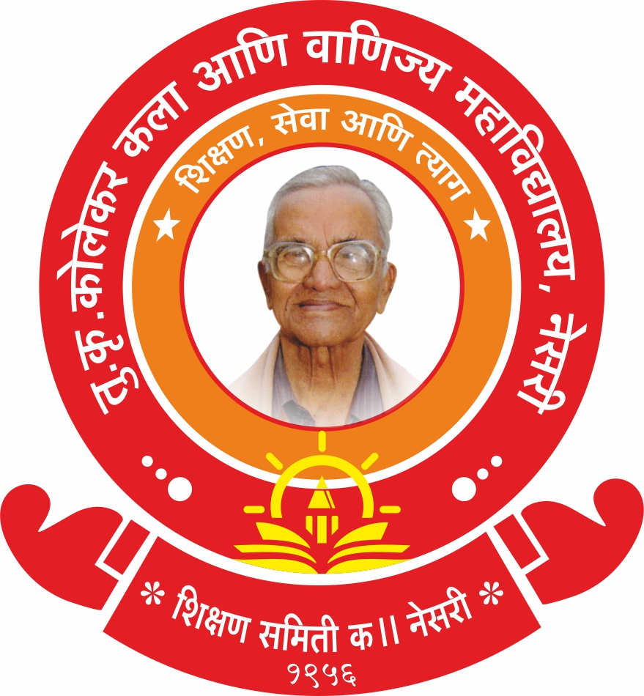

The Institution has Several Collaborations/Linkages for Faculty Exchange, Student Exchange, Internship, Field Trip, On-The- Job Training, Research etc.

Academic Year: 2023-24
Sr. No. | Title of the Collaborative Activity | Name of the Collaborating Agency with Contact details | Name of the Participant | Date of Collaboration | Duration | Nature of the Activity | No. of Participants
1 | Lecture on: Marathi Language and Earning Opportunities.  (मराठी भाषा व अर्थार्जनाच्या संधी)  Dt. 18-9-2023 | Arts, Commerce & Science  College Kowad.  Tal. - Chandgad.  Phone No- 2320235220 | Dr. R.D. Kamble | 29-Oct-21 | Five Years | Exchange of Faculty | 10
2 | Lecture on: Stages of Evolution of Indian Currency.  (भारतीय चलनाच्या उत्क्रांतीचे टप्पे)  Dt. 9-10-2023 | Raja Shiv Chhatrapati College, Mahagao  Tal- Gadhinglaj.  Email- principal.rsccollege@gmail.com | Dr. K. P. Deshamukh | 08-Oct-21 | Five Years | Exchange of Faculty | 25
3 | Lecture on: Literature. (साहित्यशास्त्र)  Dt. 14-08-2023 | Arts, Commerce & Science College Kowad. Tal. - Chandgad.  Phone No- 2320235220 | Dr. A. K. Kamble | 14-8-2023 | Five Years | Exchange of Faculty | 15
4 | Lecture on: Elections in four States: Political Analysis.  (चार राज्यांच्या निवडणूका राजकीय चिकित्सा)  Dt. 08-12-2023 | Raja Shiv Chhatrapati College, Mahagao  Tal- Gadhinglaj.  Email- principal.rsccollege@gmail.com | Dr. S. K. Suryavanshi | 08-Oct-21 | Five Years | Exchange of Faculty | 37
5 | Lecture on: The Tragedy of Othello: A Study of Jealousy, Betrayal and Revenge.  Dt.1-12-2023 | Chh. Rajarshi Shahu Arts and Commerce College, Rukadi  Mob. No. 8805909873 | Dr. Prashant Kamble | 25-Nov-2021 | Five Years | Exchange of Faculty | 26
6 | Lecture on: History of the Marathas.  (मराठ्यांचा इतिहास) | Raja Shiv Chhatrapati College, Mahagao  Tal- Gadhinglaj.  Email- principal.rsccollege@gmail.com | Dr. D, G. Kapure | 08-Oct-21 | Five Years | Exchange of Faculty | 24
7 | Seminar on: History of Modern Maharashtra. (आधुनिक महाराष्ट्राचा इतिहास)  Dt. 15-09-2023 | Arts, Commerce & Science  College, Gadhinglaj Tal- Gadhinglaj  Prin.- 9975586713 | Shri. Prashant Kamble | 12-9-2023 | Five Years | Exchange of Faculty | 24
8 | Lamanwada Survey (लमाणवाडा सर्वेक्षण)  Dt. 21/2/2024 | लमाणवाडा  ता, गडहिंग्लज | Prof. A. A. Desai &  Dr. H. S. Kuchekar | -- | -- | Field trip / Survey | 12

